My Activities

1. My Activities – Page Overview
The My Activities section serves as the main interface for users to execute their assigned tasks within MOS. It offers a centralized and organized view of all activities attributed to each user, consolidating assignments from various workflows. This unified perspective ensures that users can efficiently manage and track their responsibilities.
Access to activities within My Activities is determined dynamically at runtime. The visibility of content, as well as the range of actions that a user can perform, depends on several factors:
- User’s Assigned Roles (Permissions): The permissions granted to a user govern which actions and information they can access.
- RACI Role for Each Workflow Step: The user’s specific RACI (Responsible, Accountable, Consulted, Informed) designation for individual workflow steps further influences what they can see and do.
- Approval Responsibilities: Any approval duties that have been assigned to the user within workflows also impact on the activities and options available to them.
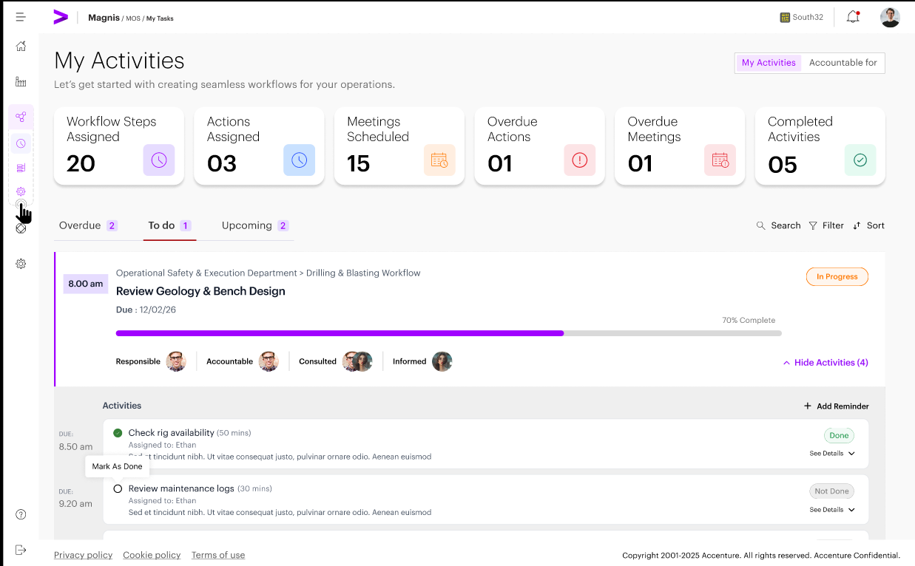

2. Activity Visibility Rules
Activity visibility within My Activities is governed by a combination of role permissions and RACI assignments at the workflow step level. These rules ensure that users have access only to the information and actions relevant to their assigned responsibilities, supporting both security and efficient task management.

2.1 Responsible (R) Visibility.
Users assigned as Responsible (R) at the workflow step level shall:
- See all workflow steps where they are listed as Responsible
- See only those activities within the step that are explicitly assigned to them
If multiple Responsible users exist for a step:
- All Responsible users shall see the step
- Only the user assigned to an activity shall see that activity
- Responsible users without assigned activities shall see the step but no activities under it

2.2 Accountable (A) Visibility
Users assigned as Accountable (A) for a workflow step shall:
- See all workflow steps where they are Accountable
- See all activities under those steps, regardless of assignee
- Access the Accountable For dashboard for monitoring execution

2.3 Consulted (C) and Informed (I) Visibility
Users assigned as Consulted (C) or Informed (I):
- Shall not see workflow steps or activities (except meeting) in My Activities
- Shall see meeting activities only if they are participants
- Shall have no execution or approval capabilities
Note: VD Screens to be updated

2.4 Action Activity Visibility
- Users assigned as Responsible (R) shall see action activities that are currently assigned to them in My Activities, consistent with Responsible (R) visibility rules.
- For each action activity, the user’s view shall present enough context to understand what needs to be done and where it sits (step and linked references).
- Workflow Step – the step card/row that contains the action activity (step name/description as available).
  - Action Activity – the action/task activity card that requires the Responsible user’s execution (title, status, and primary execution controls).
  - Assigned to – Name of the responsible user to whom the activity is assigned to.
  - Action execution actions: Mark as Done and Undo Done
  - Action execution context: Detailed description/ instructions on the activity assigned
  - Linked references: the ability to open/view any linked supporting material (e.g., URLs provided in the Action activity Comment)
Note: VD Screens to be updated

2.5 Meeting Activity Visibility
- Meeting activities shall be visible to users who are participants (including users assigned as Consulted (C) or Informed (I) for the step).
- For each meeting, the participant’s view shall present enough context to understand what the meeting is for and where it sits (step and linked references).
- Workflow Step – the step card/row that contains the meeting activity (step name/description as available).
  - Meeting Activity – the meeting activity card that requires the participant’s engagement (title, status, and participant controls as applicable).
  - Meeting details – the meeting title, scheduled date/time, location or join method (Offline/Online),Teams Link(If it’s an online meeting) and current status (Scheduled/Completed).
  - Only the meeting Organizer can mark the meeting activity as Completed
  - All configured participants shall see the meeting activity in My Activities, but they shall not be permitted to mark it as Completed.
  - When the Organizer marks the meeting activity as Completed, the Completed status shall be reflected for all users who have visibility of the activity (Organizer and all participants).
Note: VD Screens to be updated

2.6 Approval Flow Visibility
- Users assigned as Approvers shall see approval activities that are currently pending their action in My Activities.
- For each pending approval, the Approver’s view shall present enough context to understand what is being approved and where it sits (step and linked action reference). The approval card does not need to display workflow name or workflow state for MVP.
  - Workflow Step – the step card/row that contains the approval (step name/description as available).
  - Approval Activity – the approval activity card that requires the Approver’s decision (title, status, and approve/reject controls).
- Linked Action Activity – the specific action/task activity that the approval is associated with.
  - Approval decision actions: Approve and Reject (Reject requires a mandatory comment).
  - Linked action reference: the name of the linked action activity and the ability to open/view its details (read-only) for verification before approving.
  - Requester/originator: the user who submitted the item for approval, including their provided approval context (comment and/or URL), if any.

Note: VD Screens to be updated

3. Accountable For – Dashboard Behavior (MVP)
The Accountable For dashboard provides users assigned as Accountable (A) with a monitoring view of workflow execution for the steps they are accountable for. This dashboard helps Accountable users manage by exception without enabling them to execute tasks on behalf of others.
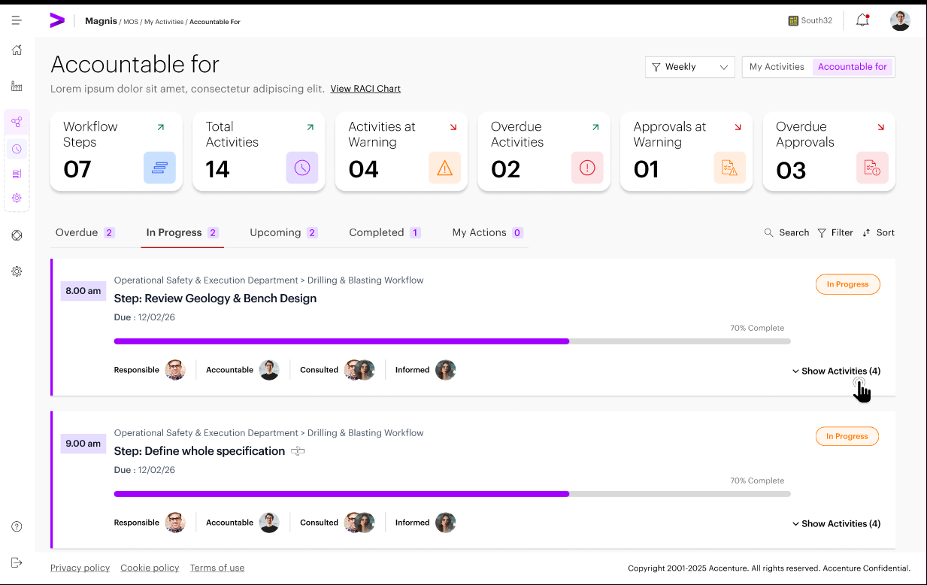

3.1 Access and Eligibility Rules
Eligibility Criteria
- The Accountable For dashboard shall be visible only to users assigned as Accountable (A) for one or more workflow steps
- If a user is not assigned as Accountable (A) in any active workflow, the Accountable For dashboard shall not be displayed, and the tab selector on the top right shall not be shown.
Role Independence
- Access to the Accountable For dashboard is independent of user roles
- Assignment to a Supervisor or Worker role is not required
- RACI assignment alone determines access

3.2 Accountable For Behavior -
- Open My Activities and switch to Accountable For: If the user is Accountable (A) for at least one step in any active workflow, the top-right tab selector is shown, and the user can select Accountable For. If the user is not Accountable for any step, the tab selector is hidden, and this view is not accessible.

- Dashboard header and KPI tiles: The Accountable For dashboard provides key performance indicator (KPI) tiles at the top of the view. These summary tiles highlight important metrics and exceptions that require the attention of users assigned as Accountable (A) for workflow steps.
  - Workflow Steps: Displays the total number of workflow steps for which the user is accountable.
  - Total Activities: Indicates the cumulative count of activities within the accountable workflow steps.
  - Activities at Warning: Shows the number of activities that are approaching their due dates
  - Overdue Activities: Reflects the total number of activities that have passed their due dates and require immediate attention.
  - Approvals at Warning: Indicates the count of approval activities that are nearing their deadlines.
  - Overdue Approvals: Displays the number of approval activities that are overdue and may impact workflow progression.
- Accountable scope Below the KPI area, the list shows only workflow steps where the user is Accountable (A). Steps where the user is not Accountable shall not be shown.
- Hierarchy and drill-down: The list supports expand/collapse in the following hierarchy: Workflow → Step → Activities. Expanding a workflow reveals the accountable steps within it; expanding a step reveals the activities within that step.
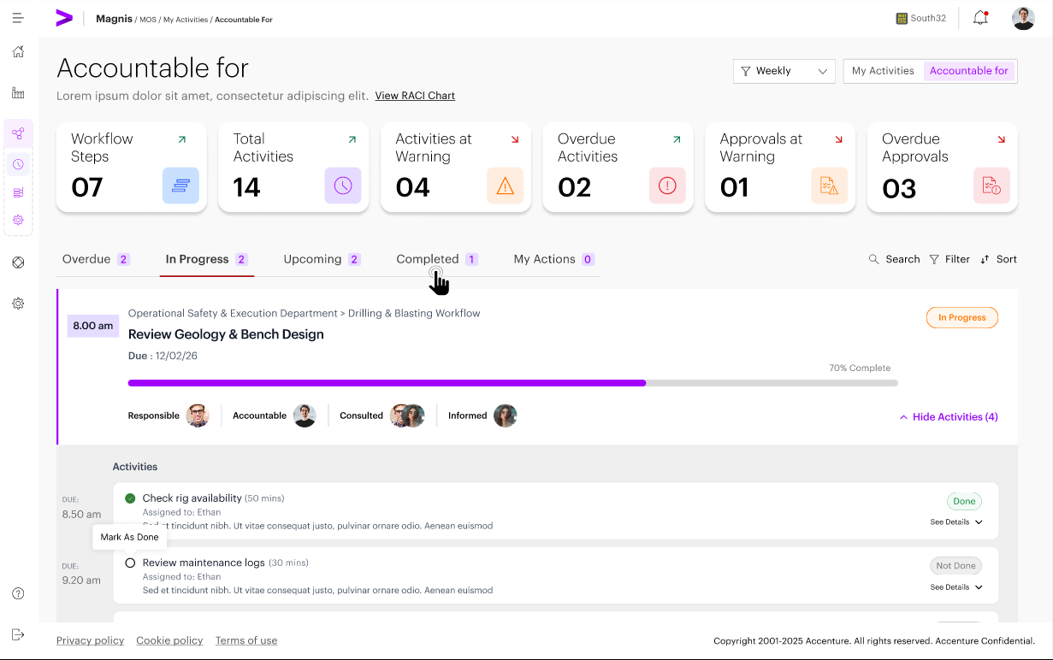
- Progress and completion visibility: Each workflow/step row provides completion and progress visibility so an Accountable user can quickly assess execution health. Also three different tabs above the workflow provide visibility on
  - Overdue – Steps/ Activities that are overdue.
  - Ongoing - Steps/ Activities that are ongoing.
  - Upcoming - Steps/ Activities that are to be expected in future.
  - Completed - Steps/ Activities that are completed.
- Approvals visibility (where applicable): For steps containing approval activities, the dashboard shows approval status information, including Pending, Approved, and Rejected states.
- Rejection impact visibility: Rejected approvals are clearly flagged. If downstream steps are configured to depend on the rejected approval, those dependent steps are shown as blocked until re-approval is completed.
- Activity Log - By clicking on the activity log, the user can have a visibility of timelines of activities highlighting delays or overdue items

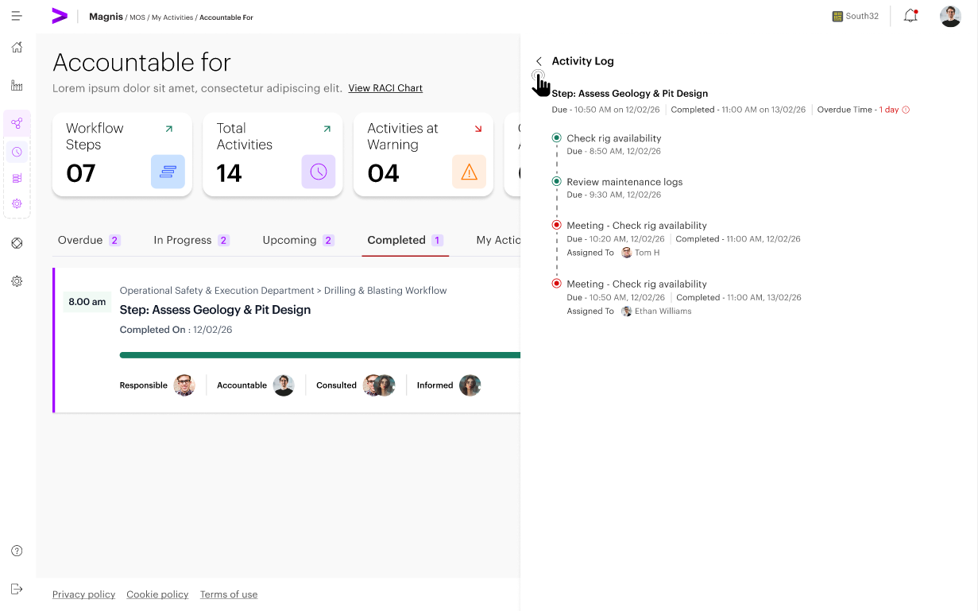

Note - Updated VDs are to be updated.

3.3 Restrictions and Non-Capabilities
RACI Chart Access: The RACI chart (Responsible, Accountable, Consulted, Informed) shall be accessible from the Accountable For. The design shall support large workflows with many rows/columns (e.g., scrollable layout) so the chart remains usable at scale.
- Add, edit, or delete workflow steps/activities (workflow structure changes are restricted to the Workflow Builder).
- Execute or complete activities from this dashboard as the execution occurs in My Activities.
- Approve activities unless the user is the assigned approver for the specific approval activity.
- Override execution or approval outcomes.

4. My Actions – Personal Actions
The My Actions tab lets users create and manage standalone personal to-do items that are not part of any workflow. These personal actions can be reassigned to other users and do not impact workflow progress, dependencies, or compliance metrics. Personal actions are created and managed only through the My Actions in My Activities Page.

4.1 Capabilities
Within the My Actions tab, users are provided with several essential capabilities to help manage their individual tasks. Specifically, users can:
- Create personal actions to track tasks that are not part of any predefined workflow.
- Assign a personal action to another system user. Upon assignment, the personal action shall be removed from the creator’s personal actions list and added to the assigned user’s personal actions list.
- Edit personal actions, allowing updates and modifications as circumstances change.
- Delete personal actions to remove tasks that are no longer relevant or required.
- Mark personal actions as completed once the associated task has been fulfilled.

4.2 Ownership and Scope
- Personal actions are exclusively owned by the user who created them.
- These actions remain private and are visible only to their owner, ensuring confidentiality and individual task management.
- Personal actions operate independently and do not affect workflow progress, dependencies, or compliance metrics within the broader system.
Note : Updated VD Screens will be placed soon

5. Summary Metrics Section
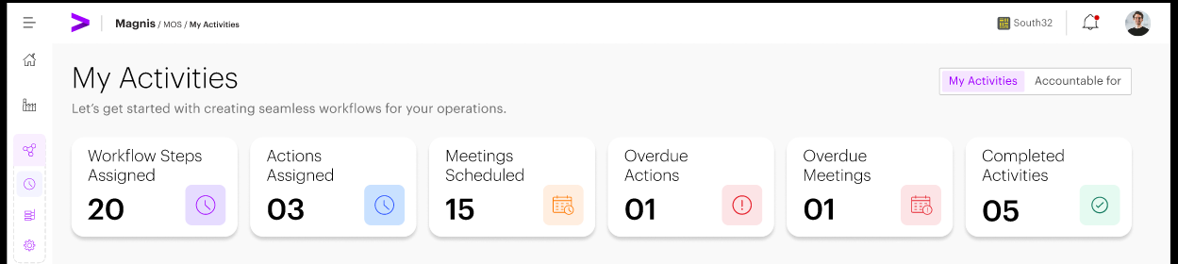
The top section of the My Activities page displays summary-level activity metrics to provide users with immediate operational awareness. Each metric represents a distinct aspect of activity status to help users quickly assess their current responsibilities and progress. All the tiles shall be clickable and navigate the user to the respective section
- Workflow Steps To Do: The total number of workflow steps currently in progress/ assigned to the user, including all states and statuses.
- Actions To Do: Activities that are scheduled for future execution and are not yet actionable, either due to future start times or dependencies that have not been met.
- Meetings Scheduled: This status shows number of meetings scheduled. It helps users track official meetings and improves visibility for participants, making it easier to organize tasks and prepare for discussions or decisions.
• Overdue Activities: Indicates the number of overdue activities. This tile shall be clickable and take the user to the Overdue tab showing the list of overdue items.

- Completed Activities: Displays the number of completed activities.
These metrics update dynamically based on activity status and are intended for informational and situational awareness purposes only. They do not serve as navigation controls.
Note: VD Screens to be updated

6. Activity Filter Bar
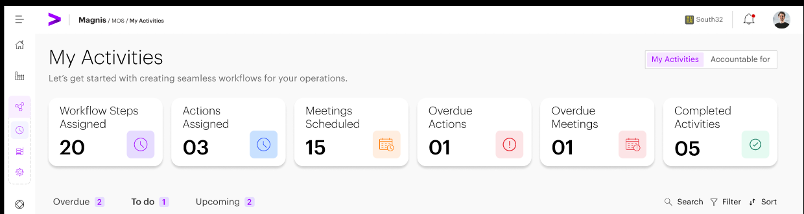
Activity filtering is enabled through a horizontal filter bar positioned below the summary metrics.
The filter bar allows users to toggle between the following activity states:
- Overdue – Activities that have passed their scheduled due time
- To Do – Active and unlocked activities that are ready for execution
- Upcoming – Activities that are not yet actionable due to future start times or unmet dependencies
- Completed – Activities that have been completed by the user.
- My Actions - Activities that are personally assigned / created by the user for working on the activities. This will also display personal actions assigned by other users to that individual user
In addition to state-based filtering, the filter bar provides:
- Search Functionality: Users can quickly locate specific activities by entering search terms related to the activity’s name or its context. This allows for rapid identification and access to relevant tasks within the workflow.
- Filter Options: The Filter functionality allows users to systematically narrow down data sets based on predefined criteria, helping them focus only on what is relevant to their role, responsibility, and timeframe.
  - Key Objectives of Filter
    - Filters allow users to limit results based on attributes such as:
    - Timeframe (This Week, This Month, Upcoming)
    - Workflow (filter by workflow name)
- Search Controls: The Search functionality enables users to instantly locate specific items without manually scanning long lists or dashboards.
  - Key Objectives of Search
    - Allows users to quickly find workflows, steps, activities, or meetings by searching on attributes such as:
    - Workflow name
    - Step name
    - Activity or meeting title
    - Owner / Responsible / Accountable user
This horizontal filter mechanism replaces the need for a persistent left-hand navigation pane and ensures a focused execution experience.
Note: VD Screens to be updated

7. Activity Detail & Execution Interaction
Activity details are accessed and executed inline within the workflow step context. When a user interacts with an activity card, the following information and actions are available inline or through an expandable view:
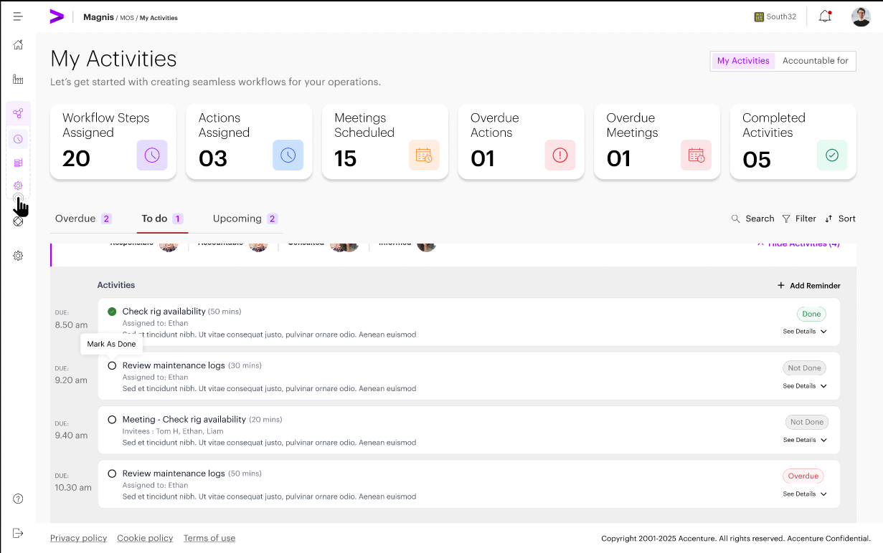
- Activity Title and Description: Each activity includes a clear name and a brief description, providing users with an immediate understanding of the activity's purpose and requirements.
- Activity Type: Activities are categorized as Action, Meeting, Approvals allowing for appropriate handling and differentiation within the workflow.
- Action: Tasks or items that require direct execution or completion by users.
- Meeting: Scheduled discussions or collaborative sessions that involve participants coming together, either virtually or in person.
- Approval: Activities that necessitate review and authorization, ensuring that certain steps are formally validated before proceeding.
- Due Time: The scheduled deadline or time for each activity is specified, enabling users to manage and prioritize time-sensitive tasks efficiently.
- Current Status: Activity status shall be displayed as Done or Not Done. Where applicable, the system shall display additional state indicators as separate pill badges adjacent to the status pill, including Overdue and Waiting Dependency.
- Dependency Indicator: Activities may be linked to dependencies, which are clearly indicated to ensure that users are aware of prerequisite actions that must be completed before proceeding.
  - If an activity or workflow step has no configured dependencies, the dependency status indicator shall not be displayed in:
  - Activity cards
  - Step tables
  - Exception indicators
  - Dependency indicators shall appear only when at least one dependency exist
- Primary Execution Action: Key actions, such as "Mark as Done," are provided to allow users to directly manage and complete activities within their workflow step context.
- Action Activity Comments -
- The system shall provide a Comment field for each Action activity at runtime (i.e., during execution).
- The Comment field shall support rich text (RTF) and must render clickable URLs (e.g., a pasted link to a document or file location) so that an Approver can follow the link to review supporting material.
- For action activities that require approval, the Comment content shall be visible to the Approver when reviewing the associated approval activity.
- After an action activity is marked Done, the Comment shall be displayed within the completed activity (at the bottom of the activity detail) and remain readable with clickable URLs.
- Once the workflow step is completed, the Comment shall be read-only. The Comment shall become editable again only if the user performs an Undo Completion action for the step (or equivalent uncomplete/reopen behavior).
Note : Updated VD Screens will be placed soon

8. Activity Execution Rules
The following rules govern activity execution within the My Activities page:
- Activities become actionable only when all defined dependencies are marked as done.
Execution Rules
- Users who are tagged as ‘Assigned To’ for an activity have specific permissions and responsibilities within the system.
- Upon completion of the required tasks, Responsible users must mark the activity as completed in the system.
- Add personal actions for self-management
- Additionally, if the activity requires any specific inputs or supporting material as part of its configuration, users shall provide these details in the Action activity Comment field (rich text), including pasting any relevant document/file URLs where applicable.
Dependency Handling
- In cases where an activity is dependent on the completion of other activities, such dependencies are clearly indicated in the system.
- Activities that are blocked by unresolved dependencies are displayed with a status of "Waiting Dependency."
- While an activity is blocked, Responsible users are unable to execute or start the activity.
- Once the necessary dependencies are resolved, the system will automatically update the status of the activity, allowing execution to proceed.
Activity Reassignment Rules
The following rules govern activity reassignment:
- Only Workflow Builder or Client Admin may reassign activities
- Reassignment is allowed only at the activity level, not at the workflow or step level
- The new assignee must be a valid user within the same client instance
- Reassignment does not alter the workflow structure or RACI assignments
Workflow Builder can:
- Modify workflow steps
- Change RACI assignments
- Bypass defined dependencies
Note : Updated VD Screens will be placed soon

9 Approval of Activities
Actions Performed by Approvers
- Users who are assigned the Assignment type of Approver have the authority to take specific actions on workflow activities.
- Approvers can formally approve an activity, thereby allowing it to move forward within the workflow. I
- If an Approver decides to reject an activity, they are required to provide a comment explaining the reason for the rejection. This comment is required so everyone understands why the decision was made.
Approval Status Handling
- A workflow step may have multiple Responsible (R) users, each with their own set of assigned activities to execute. The system shall allow Responsible users to continue executing their assigned activities in parallel; the step shall remain Incomplete until all required activities for the step (including any required approval activities) are completed.
- If an activity following an approval activity is configured as dependent on that approval, it shall remain Blocked until the approval is completed; activities that are not configured as dependent on the approval may proceed as normal.
- The current approval status for each workflow step is made visible in both the "My Activities" and "Accountable For" views, providing transparency and easy access to status information for all relevant users.

10. Rejection and Resubmission
Rejection Handling
- A workflow step may have multiple Responsible (R) users, each with their own set of assigned activities to execute. The system shall allow Responsible users to continue executing their assigned activities in parallel; the step shall remain Incomplete until all required activities for the step (including any required approval activities) are completed.
- If an activity following an approval activity is configured as dependent on that approval, it shall remain Blocked until the approval is completed; activities that are not configured as dependent on the approval may proceed as normal
- Visibility of Rejection Comments: All comments associated with the rejection decision are made visible to the user responsible for the rejected activity. This ensures transparency and provides clear guidance for resubmission.
Resubmission
- Activity Update and Resubmission: The responsible user has the ability to modify the rejected activity according to the feedback provided and submit the updated activity again for approval.
- New Approval Cycle: Each time the activity is resubmitted, a brand new approval cycle is initiated, distinct from previous approval attempts.

11. Due Dates, Duration and Progress of Activities
Duration and Due Date Logic
- The duration of an activity specifies the expected amount of effort required to complete it.
- The due date/time for an activity is determined by combining its start time with the assigned duration.
- If either the duration or the due date is updated, the system will automatically recalculate the other value to ensure consistency and accuracy in scheduling.
Progress Calculation
- Workflow progress is measured based on the number of activities that have been completed.
- Approval activities are counted toward the overall progress only after they have been approved, ensuring that only finalized tasks contribute to workflow advancement.
Note : Updated VD Screens will be placed soon

12. Notifications and Alerts
The system is designed to generate notifications to keep users informed and prompt timely actions. Notifications are triggered in the following scenarios:
- When a new activity is assigned to a user, the system will send a notification to ensure the assignee is aware of their new responsibility.
- If there are approvals pending action, users will receive notifications prompting them to review and complete the required approval tasks.
- For activities that have become overdue, notifications will be generated to alert users about the missed deadlines and encourage corrective action.
- For activities that are approved, the user will be notified on the same via email
- In cases where activities are rejected or require resubmission, notifications will be sent to inform users of the rejection and the need to resubmit the activity for approval.
Notifications are typically delivered through email and in app notification feature ensuring that recipients receive timely updates regarding their workflow activities and approvals.

